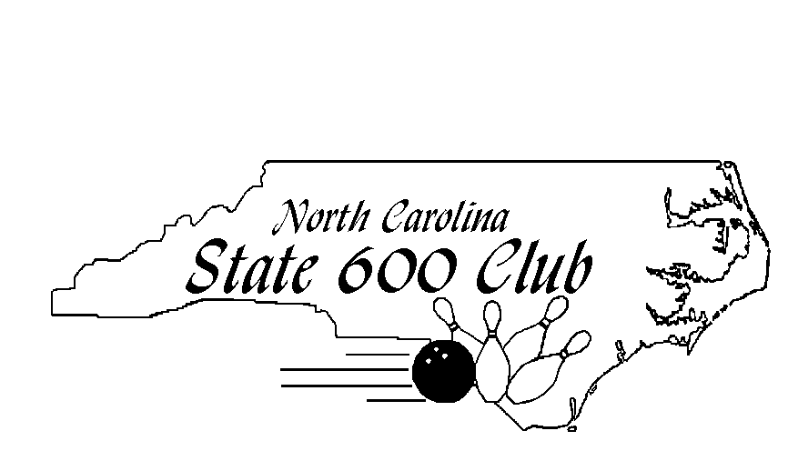
October 15th, 2017

19th Annual NC Women’s 600 Club Tournament

Pla Mor Lanes
2505 Davie Ave
Statesville, NC 28625
(704) 903-8335
Annual Meeting: 10:00 AM
Tournament Check In: 11:15 AM
Tournament Start: 12:00 PM
Early Entries Close: Oct 9th, 2017
(Entries after this date will be $5 extra—Goes to Prize Fund)

Tournament Fees:

NEW DIVISION FORMAT!!
Two Average Divisions
Below 174 & Above 175
90% of 220
Youth Bowlers Welcome!

Entry Fee $45
Optional Scratch Division $10 (paying 1:6)
Handicap and Scratch Sidepots will be available

Entry Form
Name: ____________________________________ Phone: ____________________________
Address: _____________________________________________________________________
Email: ___________________________________ 2016/17 Highest Yearbook Avg: _________
USBC Sanction Card # ______________________ NC 600 Club #________________________

For more information visit our new website: www.nc600club.com
And Like us on Facebook at www.facebook.com/nc600club

Make Checks Payable to: NC State 600 Club
Send Entries to: Angel Metsch, Tournament Director
2505 Davie Ave
Statesville, NC 28625
Phone: (704)903-8335

